SAFEFRUIT AI

1 Introduction
The modern agricultural and food processing industries face severe challenges regarding food safety, quality control, and post-harvest loss management. Manual inspection of fruits and produce in processing plants or distribution centers is inherently labor-intensive, slow, subjective, and prone to human error. Furthermore, external surface appearance does not always reveal chemical contamination or early microbial decay, leading to food waste and potential health hazards.
To address these critical challenges, SAFEFRUIT AI was developed as an intelligent, automated multi-stage fruit inspection, cleaning, sterilization, and sorting system. The system integrates Artificial Intelligence (AI), Computer Vision, Internet of Things (IoT) sensors, and mechanical automation into a unified pipeline.
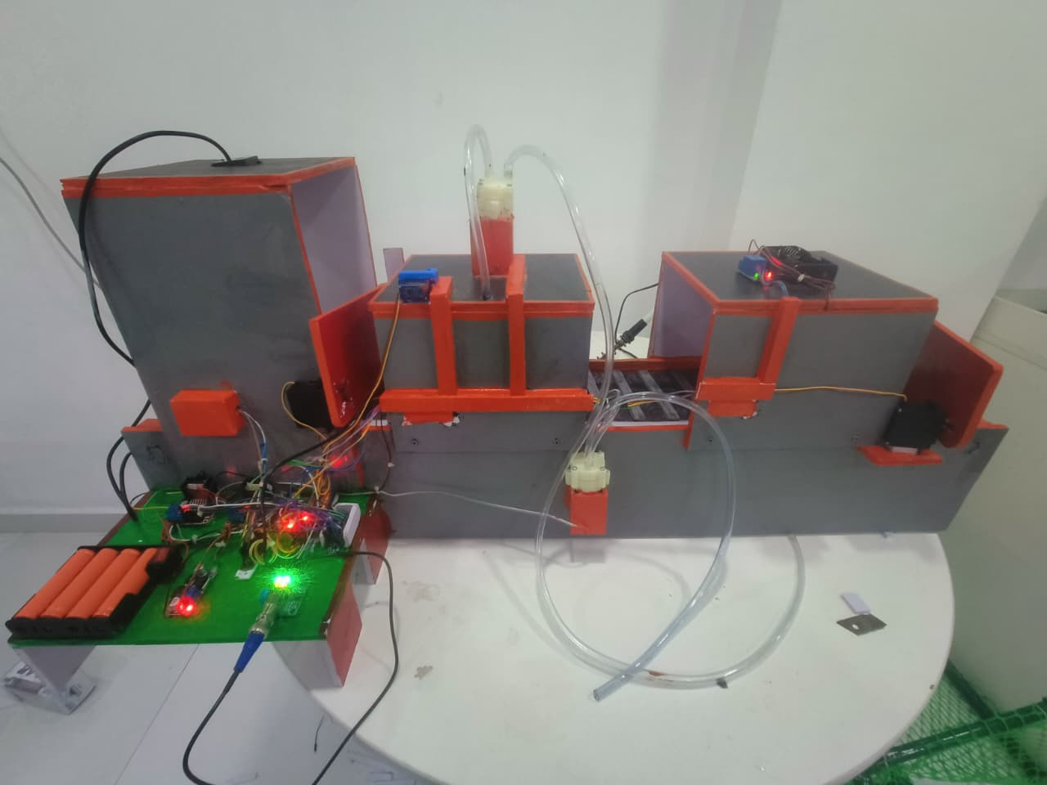
SAFEFRUIT AI evaluates fruit quality across three distinct hardware and software stages:
- Stage 1 (Vision Inspection): Utilizes Computer Vision and the Google Gemini 2.5 Flash Model to detect, classify, and evaluate surface defects and overall fruit condition.
- Stage 2 (Washing & Chemical Sensing): Performs high-pressure water washing while dynamically monitoring volatile spoilage gases (MQ135) and water acidity/alkalinity (pH Sensor) via motorized sensor insertion.
- Stage 3 (UV Sterilization & Sorting): Executes short-wave ultraviolet (UV-C) surface sterilization and dynamically routes the fruit into a Healthy Bin or Waste Bin using servo-driven diverter gates.

1.1 Sustainable Development Goals (SDGs)
SAFEFRUIT AI directly aligns with global sustainability initiatives, specifically contributing to three United Nations Sustainable Development Goals:
- SDG 2: Zero Hunger: By minimizing post-harvest loss through early detection of chemical rot and microbial contamination, the system helps preserve available food supplies.
- SDG 3: Good Health and Well-Being: Through automated UV sterilization and chemical contamination detection, the system prevents contaminated produce from reaching human consumers.
- SDG 12: Responsible Consumption and Production: Automated sorting ensures efficient food distribution pipelines, reducing waste across the supply chain.
1.2 Project Objectives
The core objectives of the SAFEFRUIT AI system are:
- Automate Fruit Identification & Defect Detection: Deploy multi-modal vision models to classify fruit species and identify surface rot, physical bruises, or mold in real time.
- Chemical & Spoilage Sensing: Integrate gas and pH sensors to measure volatile organic compounds (VOCs) and acidity levels, identifying invisible chemical decay.
- Sanitization and Decontamination: Perform targeted automated washing and UV LED surface sterilization to eliminate pathogens.
- Autonomous Sorting: Mechanically direct fruits into distinct bins based on aggregated physical, chemical, and visual quality metrics.
- Centralized Telemetry & Teleoperation: Provide a real-time web dashboard for system monitoring, live camera streams, operational controls, and historical logs.
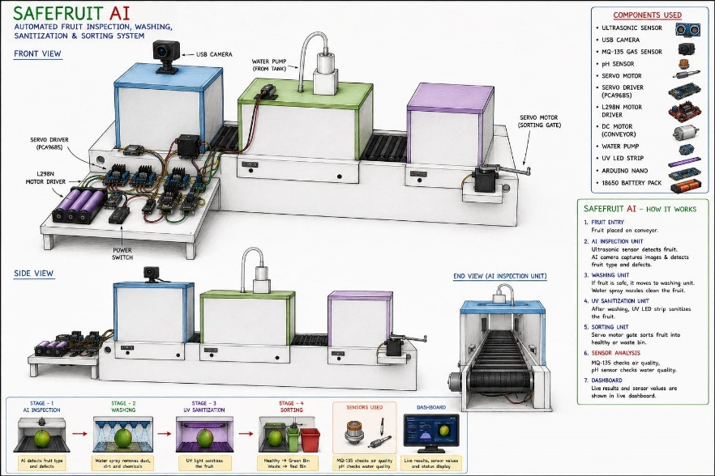
2 Problem Statement
2.1 Existing Problems
Traditional post-harvest fruit handling and sorting systems rely on manual labor or simplistic color-sorting machinery. These conventional approaches exhibit critical limitations:
- High Subjectivity and Labor Costs: Human operators experience fatigue, leading to inconsistent defect grading over extended operational shifts.
- Inability to Detect Early Chemical Decay: Visual inspection alone cannot detect micro-bacterial activity or early chemical spoilage, allowing rotting fruit to infect healthy batches.
- Lack of Decontamination Integration: Standard sorting lines separate produce but do not clean or sterilize items during the inspection phase, requiring separate processing lines.
- Opaque Process Data: Traditional machines lack modern Web/IoT reporting interfaces, preventing real-time quality control logging.
2.2 Proposed Solution
SAFEFRUIT AI resolves these issues by combining vision-based deep learning models with hardware sensor feedback on a continuous mechanical conveyor system.
[ Fruit Intake via Conveyor ]
│
▼
[ Stage 1: Vision Inspection & AI Analysis ]
│
┌───────────┴───────────┐
▼ ▼
[ Rejected ] [ Approved ]
│ │
│ ▼
│ [ Stage 2: Washing & Sensing ]
│ │
│ ┌───────────┴───────────┐
│ ▼ ▼
│ [ Rejected ] [ Approved ]
│ │ │
│ │ ▼
│ │ [ Stage 3: UV Sterilization ]
│ │ │
└───────────┼───────────────────────┘
│
▼
[ Servo Gate Diverter ]
├──► Healthy Bin
└──► Waste Bin
The system subjects each item to sequential physical and chemical quality checks, ensuring that only clean, disease-free, and undamaged produce enters the consumer distribution chain.
2.3 Objectives
- Build an automated hardware conveyor line driven by an Arduino Nano and a PCA9685 servo driver.
- Implement real-time visual assessment via OpenCV and Google Gemini 2.5 Flash API.
- Implement automated gas analysis (MQ135) and fluid acidity monitoring (pH sensor) controlled by servo lift mechanisms.
- Implement dual-pump washing and UV-C LED sterilization cycles.
- Develop a Flask-based telemetry dashboard for real-time visualization and remote control.
2.4 Key Innovations
- Multi-Stage Hybrid Decision Logic: Combines deep learning visual analysis with analog chemical sensor inputs for accurate health evaluations.
- Motorized Actuated Sensor Probing: Uses a dedicated servo mechanism to lower sensitive probe elements directly over or into the testing zone during inspection cycles, extending sensor lifespan.
- Real-time AI Vision Diagnostics: Directly processes high-resolution imagery using Google Gemini 2.5 Flash to extract fruit identity, structural condition, defect reasoning, and confidence metrics in single-pass inference.
- Full-Stack Modular Architecture: Communicates via serial commands using a Python backend and an HTML/CSS/JS frontend.
3 System Architecture
3.1 Overall Architecture
The system architecture combines hardware microcontrollers, analog/digital sensors, high-torque actuators, a host workstation running a Flask server, and external AI vision APIs.
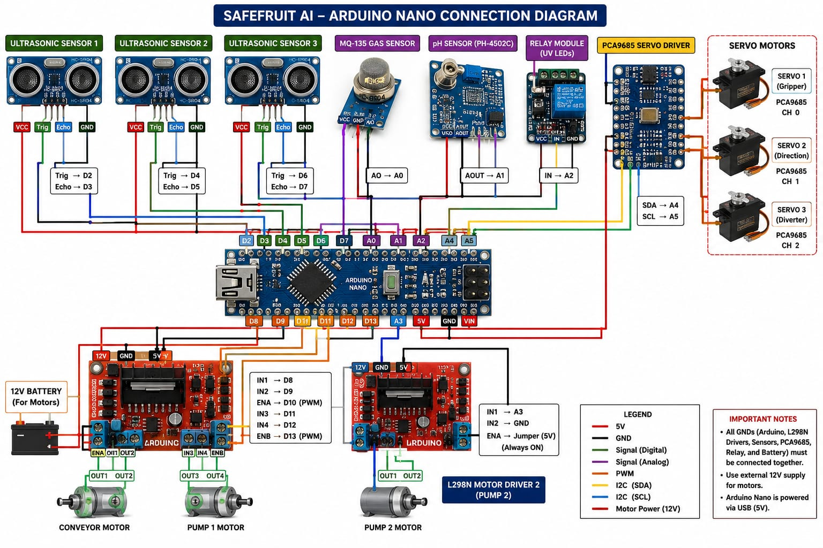The system operates across three core abstraction layers:
- Perception & Actuation Layer (Hardware): Arduino Nano, PCA9685 PWM Driver, HC-SR04 Ultrasonic Sensor, MQ135 Gas Sensor, pH Sensor, Servo Motors, L298N Motor Drivers, Relays, UV LED Strips, and Water Pumps.
- Processing & Intelligence Layer (Software/AI): Host Laptop running Python, OpenCV, Serial Interfacing, and the Google Gemini 2.5 Flash Vision API.
- User Interaction Layer (Dashboard): Responsive Web Dashboard built with Flask, HTML5, CSS3, JavaScript, and Server-Sent Event / Polling links.

3.2 Working Flow
The mechanical and computational flow follows a systematic lifecycle across the inspection stages:
START
│
▼
Power ON the System
│
▼
Arduino Nano & Python Application Start
│
▼
USB Camera, Sensors & Dashboard Initialize
│
▼
Ultrasonic Sensor Detects Incoming Fruit
│
▼
Conveyor Belt Starts Moving
│
▼
Fruit Stops at Camera Position
│
▼
USB Camera Captures Multiple Images
(6–8 Images)
│
▼
Images Sent to Gemini 2.5 Flash AI
│
▼
AI Identifies Fruit Name & Fruit Type
│
▼
AI Detects Surface Defects, Mold, Rot,
Brown Spots, Black Spots, Damage
│
▼
Is Surface Quality Acceptable?
┌────────┴────────┐
│ │
YES NO
│ │
▼ ▼
Conveyor Moves Servo Opens
Fruit to Stage 2 Waste Gate
│ │
│ Fruit → Waste Bin
│ │
└────────► END ◄──┘
│
▼
Fruit Enters Washing Tank
│
▼
Water Pump IN Starts Washing Fruit
│
▼
Servo Lowers MQ135 & pH Sensors
│
▼
MQ135 Measures Spoilage Gas Level
│
▼
pH Sensor Measures Water Acidity
│
▼
Servo Lifts Sensors Back to Home
│
▼
Water Pump OUT Removes Dirty Water
│
▼
Are Gas & pH Values Safe?
┌────────┴────────┐
│ │
YES NO
│ │
▼ ▼
Conveyor Moves Servo Opens
Fruit to Stage 3 Waste Gate
│ │
│ Fruit → Waste Bin
│ │
└────────► END ◄──┘
│
▼
Fruit Enters UV Chamber
│
▼
Conveyor Stops Automatically
│
▼
Relay Turns ON UV LED Strips (10 sec)
│
▼
UV Sterilization Process Completed
│
▼
Relay Turns OFF UV LED Strips
│
▼
Conveyor Moves to Final Gate
│
▼
Servo Opens Healthy Fruit Gate
│
▼
Fruit Falls into Healthy Bin
│
▼
Dashboard Updates Live Results & Sensor Data
│
▼
System Ready for Next Fruit
│
▼
END

3.3 AI Workflow
The AI pipeline handles image acquisition, preprocessing, cloud inference, JSON output parsing, and hardware command execution:
Camera Frame Capture (OpenCV)
│
▼
Image Preprocessing & Encoding
│
▼
REST Request to Gemini 2.5 Flash API
│
▼
JSON Structured Response Parsing
├── Fruit Name / Type
├── Surface Defect Identification
├── Healthy / Rotten Categorization
└── Confidence Score Calculation
│
▼
Dashboard Rendering & Hardware Control

3.4 Main Features
- Continuous Object Detection: Ultrasonic sensor trigger prevents false camera reads.
- Generative AI Structural Analysis: Identifies visual defects, microbial spots, bruises, and structural rot.
- Dynamic Washing Cycle: Dual-pump water spray cleans dust and debris before chemical sensing.
- Sensor Actuation: Motorized arm lowers sensors during measurement to protect probes from physical impact during fruit movement.
- Pathogen Elimination: High-intensity UV-C LED sterilization chamber sanitizes clean produce.
- Automated Mechanical Sorting: Servo-actuated bin gates dynamically divert fruits based on evaluation results.
- Real-time Web Dashboard: Provides full monitoring control, stream views, hardware diagnostic status, and system logging.
4 Hardware Components
4.1 Hardware Overview
The hardware assembly combines structural components, mechanical actuators, fluid dynamics hardware, electro-optical sensors, and power management units.
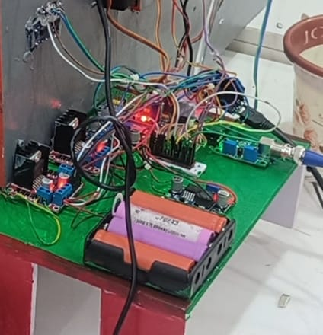

1. Arduino Nano
- Purpose: Functions as the primary real-time hardware microcontroller.
- Working Principle: ATmega328P microcontroller executing an embedded loop. Reads sensor voltage values, outputs PWM/digital signals to drivers, and handles bidirectional ASCII serial communication with the host computer at 9600 baud.
- Advantages: Compact size, low power usage, robust GPIO interfacing.
- Applications: Industrial automation, robotics, sensor telemetry.
2. Host Laptop Workstation
- Purpose: Runs the main Python application, computer vision models, local web server, and API interfaces.
- Working Principle: Multi-core x86 processor execution environment handling image encoding, HTTP network requests, and hardware control routines.
- Advantages: High computational performance for local image processing and cloud API communication.
- Applications: Edge computing, AI integration, centralized web server hosting.
3. USB Camera Module
- Purpose: Captures optical image feeds of incoming fruits in Stage 1.
- Working Principle: CMOS image sensor outputting real-time UVC video streams to Python via OpenCV.
- Advantages: Simple plug-and-play setup, auto-exposure controls, high resolution.
- Applications: Visual quality inspection, security monitoring, machine vision.
4. HC-SR04 Ultrasonic Distance Sensor
- Purpose: Detects the arrival of a fruit on the intake conveyor.
- Working Principle: Emits a 40 kHz ultrasonic burst from a transmitter transducer. The receiver transducer captures the echo pulse, and distance is calculated via time-of-flight:
- Advantages: Low cost, simple interface, accurate short-range distance sensing.
- Applications: Proximity detection, obstacle avoidance, tank level monitoring.

5. MQ135 Gas Sensor
- Purpose: Detects volatile organic compounds (VOCs), ammonia, sulfide derivatives, and spoilage gases emitted by rotting fruit.
- Working Principle: Uses a semiconductor layer whose electrical conductivity changes in the presence of target volatile gases.
- Advantages: High sensitivity to organic decay gases, fast response time.
- Applications: Environmental air monitoring, food freshness verification.
6. Analog pH Sensor & Signal Processing Board
- Purpose: Evaluates chemical runoff acidity/alkalinity during the washing phase to detect chemical contamination.
- Working Principle: Measures hydrogen ion activity via a glass bulb electrode, generating a millivolt output scaled by a signal conditioning board into an analog voltage for the Arduino ADC.
- Advantages: Highly responsive to liquid chemical composition changes.
- Applications: Water quality analysis, chemical solution tracking.
7. PCA9685 16-Channel PWM Servo Driver
- Purpose: Expands microcontroller output lines to control multiple servo motors with precise I2C timing.
- Working Principle: Communicates with the Arduino Nano over I2C (A4/A5), generating 12-bit resolution PWM outputs via an internal clock.
- Advantages: Frees processing overhead from the Arduino microcontroller, preventing servo jitter.
- Applications: Multi-axis robotic arms, multi-servo mechanical platforms.
8. Servo Motors (3 Units)
- Purpose: Operates the Stage 1 intake door, Stage 2 sensor probe lift arm, and Stage 3 exit sorting gate.
- Working Principle: Internal DC motor and gear assembly with potentiometer feedback. Maintains precise horn angles based on input PWM pulse widths
- Advantages: High torque density, precise positional control.
- Applications: Mechanical gating, robotic joint manipulation.
9. L298N Dual H-Bridge Motor Drivers (2 Units)
- Purpose: Provides high-current switching for the conveyor belt DC motor and twin fluid pumps.
- Working Principle: Dual H-bridge circuit using high-power transistors. Controls motor rotation direction and speed via PWM input signals.
- Advantages: High current capacity, independent dual-channel control, built-in thermal protection.
- Applications: DC motor direction and speed control, inductive load driving.
10. DC Conveyor Motor
- Purpose: Drives the mechanical transport belt across all inspection stages.
- Working Principle: Converts direct current electrical energy into mechanical rotation via internal magnetic fields and gear assemblies.
- Advantages: High starting torque, controllable speed via PWM.
- Applications: Automated industrial assembly lines, material transport.
11. Mini DC Water Pumps (2 Units)
- Purpose: Delivers pressurized water sprays to wash fruit surfaces in Stage 2.
- Working Principle: Centrifugal pump driven by a small DC motor, moving fluid from the reservoir to output nozzles.
- Advantages: Compact size, fast priming, simple 5V/12V DC power requirement.
- Applications: Fluid circulation, small-scale irrigation, automated washing systems.
12. Relay Module
- Purpose: Switches high-power AC/DC loads for the UV sterilization lights.
- Working Principle: Low-power digital signals energize an internal electromagnetic coil, mechanically closing high-current contacts.
- Advantages: Complete optocoupler isolation between low-voltage microcontrollers and higher-power loads.
- Applications: High-voltage switching, industrial device isolation.
13. UV LED Strips
- Purpose: Provides short-wave ultraviolet illumination to eliminate surface microorganisms on inspected fruits.
- Working Principle: Solid-state LEDs emit light in the UV spectrum, destroying microbial DNA structures.
- Advantages: Fast turn-on time, low heat generation, directional light emission.
- Applications: Surface disinfection, water purification, germicidal sanitization.
14. External Power Supply System
- Purpose: Delivers regulated 5V and 12V DC power across all system sensors, processing units, and high-current actuators.
- Working Principle: Step-down switch-mode regulation converts AC mains voltage into stable DC output rails.
- Advantages: Over-current protection, stable voltage regulation under inductive load spikes.
- Applications: Powering embedded hardware, robotics, and automation rigs.
4.2 Hardware Summary Table
Component Name | Primary Function | Electrical Specs / Interface | Stage Used
Arduino Nano | Master Real-Time Microcontroller | ATmega328P, USB-UART, 5V Logic | System Wide
USB Camera | Capture Optical Image Streams | 1080p, USB 2.0 Video Class | Stage 1
HC-SR04 | Fruit Distance Detection | Trigger/Echo, 5V DC | Stage 1
MQ135 | Spoilage Gas Detection | Analog Output ($A0$), $SnO_2$ Sensor | Stage 2
Analog pH Sensor | Fluid Acidity Measurement | Analog Output ($A1$), Glass Probe | Stage 2
PCA9685 | 16-Channel Servo Control | I2C Bus (SDA/SCL), 12-Bit PWM | Stages 1, 2, 3
Servo Motors (3x) | Gate and Sensor Actuation | 5V DC, PWM Controlled | Stages 1, 2, 3
L298N (2x) | DC Motor and Water Pump Control | Dual H-Bridge, 5V-12V Power Inputs | Stages 1, 2
DC Conveyor Motor | Mechanical Belt Transport | 12V DC, High Torque Gear Head | Stages 1-3
Water Pumps (2x) | High Pressure Surface Spray | 12V DC, Centrifugal Flow | Stage 2
Relay Module | Isolation Switch for UV Array | Optocoupler Trigger, 5V Coil | Stage 3
UV LED Strips | Surface Germicidal Treatment | 12V DC Input, Germicidal Wavelength | Stage 3
Power Supply | Central Power Generation Unit | 12V DC 5A SMPS Unit | System Wide
5 Software Components
5.1 Software Overview
The system uses a multi-tier software architecture combining a Python control backend, asynchronous web server, serial drivers, client-side rendering engine, and cloud AI connection services.
Core Software Elements:
- Python 3.x: Primary backend runtime executing machine vision algorithms, API processing, and communication loops.
- Flask Web Framework: Serves the control dashboard, exposes JSON telemetry APIs, and manages web camera video streams.
- OpenCV (Open Source Computer Vision): Manages camera acquisition, frame capture, cropping, encoding, and display streaming.
- Google Gemini 2.5 Flash API: Processes multimodal input prompts to extract visual health indicators, structural defects, and classification metadata.
- PySerial Module: Manages bidirectional serial communication over USB (COM10 / /dev/ttyUSB0) between Python and the Arduino Nano.
- HTML5 / CSS3 / JavaScript (Vanilla ES6): Renders the responsive user dashboard interface with asynchronous dynamic updating.
- Arduino C/C++ Code: Embedded sketch running on the Arduino Nano to handle low-level pin reading and motor control execution.
5.2 Software Workflow
[ Client Dashboard Interface (JS/HTML) ]
│
HTTP REST / Event Stream
│
▼
[ Flask Server Framework (Python) ]
├── OpenCV Stream Provider
├── Gemini 2.5 Flash API Interfacer
└── PySerial Driver Loop
│
Bidirectional Serial
│
▼
[ Microcontroller Sketch (Arduino) ]
├── Interrupt/Sensor Polling Routine
├── PCA9685 I2C Command Generator
└── Digital/PWM Actuator Pin Driver
5.3 Software Features
- Non-blocking Asynchronous Operations: Camera streaming, UI rendering, and serial polling execute on separate threads to prevent user interface lag.
- Structured JSON AI Prompting: Gemini 2.5 Flash is forced to return strict, parseable JSON schemas to ensure reliable downstream decision handling.
- Dynamic Telemetry Logging: Historical execution steps, sensor threshold breaches, and sorting actions are automatically logged with timestamps.
- Dynamic Peripheral Reconfiguration: Serial port assignments, camera indexes, and API keys can be adjusted dynamically via web modal dialogs.
6 Complete Working Process
6.1 Stage 1: Fruit Arrival and Identification
- Placement: The fruit is loaded onto the intake conveyor belt.
- Detection: The conveyor moves the fruit until the HC-SR04 Ultrasonic Sensor detects a object distance below the programmed threshold .
- Intake Halt: The Arduino Nano immediately stops the conveyor motor and sends an intake interrupt signal to the Python host over serial.
- Camera Capture: OpenCV grabs a clean, unblurred video frame from the USB camera overhead.
- Gemini 2.5 Analysis: The image is formatted and transmitted to the Gemini 2.5 Flash API with a structured prompt requesting classification (Fruit Name, Type, Surface Defects, Rotten/Healthy State, and Confidence Level).
- Stage 1 Decision: If classified as Rotten, the system skips subsequent processing, opens the diversion gates, moves the conveyor, and drops the fruit into the Waste Bin. If classified as Healthy, the fruit moves to Stage 2.
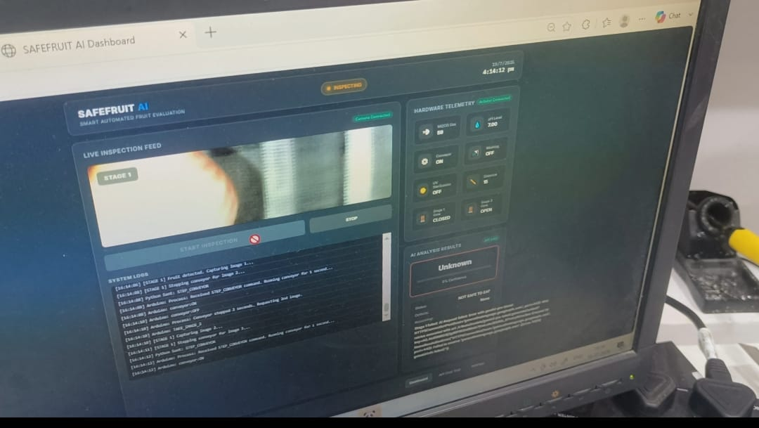
6.2 Stage 2: Washing and Chemical Inspection
- Transport: The conveyor moves the approved fruit into the enclosed washing chamber.
- Surface Washing: The Arduino Nano turns on the dual L298N Water Pumps, spraying clean water over the fruit to remove dust, mold spores, and foreign surface particles.
- Sensor Deployment: The PCA9685 Servo Driver lowers the sensor arm (Channel 1), bringing the MQ135 Gas Sensor and pH Sensor into proximity with the fruit and wash runoff.
- Data Sampling: The Arduino samples analog pins A0 (Gas) and A1 (pH) over a 3-second evaluation window.
- Chemical Evaluation:
  - If the MQ135 reading exceeds safety thresholds ($> 300\text{ PPM}$ VOCs/Ammonia), the item is flagged as decaying.
  - If the pH sensor detects significant chemical runoff acidity ($pH < 5.0$ or $pH > 8.5$), the item is flagged for chemical contamination.
- Retraction: Servo Channel 1 lifts the sensor array clear of the mechanical transport line.
- Stage 2 Decision: If chemical spoilage is detected, the item is routed to the Waste Bin. If the fruit passes, it moves to Stage 3.
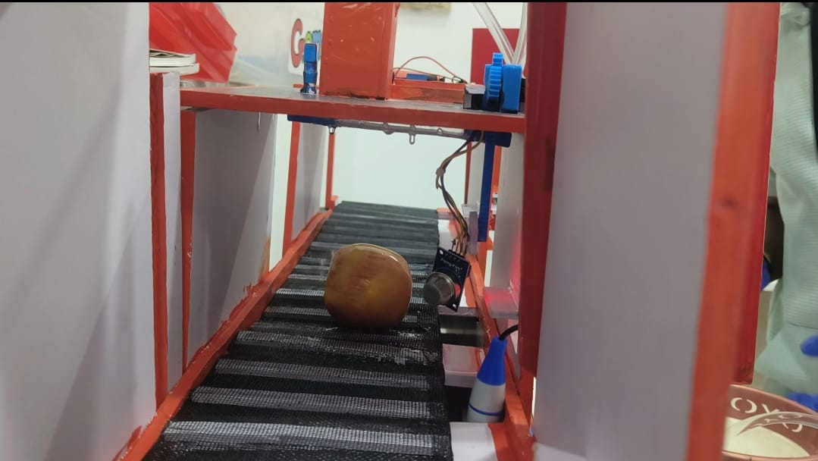
6.3 Stage 3: UV Sterilization and Dynamic Sorting
- Transport: The clean, chemically verified fruit moves into the shielded UV sterilization chamber.
- Germicidal Treatment: Relay pin D11 activates the high-intensity UV LED Strips for a precise 10-second sterilization cycle.
- Sterilization Halt: The UV arrays turn off, and the exit servo door (Channel 2) opens.
- Sorting Routing:
  - Healthy Decision: Servo Gate (Channel 2) actuates to direct the fruit into the Healthy Bin.
  - Waste Decision: Servo Gate (Channel 2) actuates to direct the fruit into the Waste Bin.
- Cycle Completion: System status updates to IDLE, dashboard telemetry clears current item states, and the conveyor prepares for the next incoming fruit.
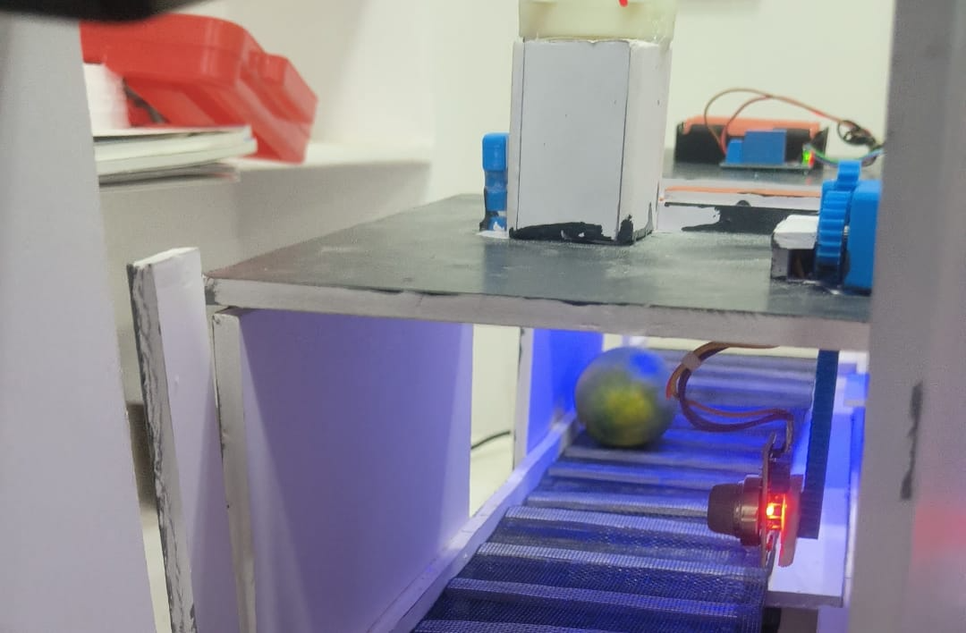
7 AI Fruit Detection
7.1 Deep Learning Vision Architecture
SAFEFRUIT AI uses the Google Gemini 2.5 Flash multimodal vision model for real-time visual inspection. The architecture processes native raw camera frames alongside embedded system system instructions, extracting deep semantic features without needing localized neural hardware accelerators.
7.2 Detection Prompt & Response Contract
To ensure predictable automated operation, the system transmits custom structured JSON instructions to the API endpoint:
JSON
{
"system_instruction": "You are an expert food quality vision model. Analyze the provided image of the fruit on the conveyor. Return ONLY a valid JSON object matching the requested schema.",
"expected_output_schema": {
"fruit_name": "string",
"fruit_type": "string",
"surface_condition": "string",
"defects_detected": ["array of strings"],
"is_healthy": "boolean",
"confidence_score": "float (0.0 to 1.0)",
"reasoning": "string"
}
}
7.3 Workflow & Decision Logic
Raw BGR Frame Captured via OpenCV
│
▼
Format Conversion (JPEG Base64)
│
▼
Google Gemini 2.5 Flash Inference
│
▼
JSON Parsing and Validation
│
┌────────────┴────────────┐
▼ ▼
[ Valid Response ] [ API Exception ]
│ │
▼ ▼
Extract Metrics Trigger Safe Retry
│ Default to Reject
▼
Check `is_healthy` Flag
├── TRUE ──► Advance to Stage 2 Washing
└── FALSE ──► Flag Defect & Halt Conveyor

8 Chemical Inspection
8.1 MQ135 Gas Analysis Pipeline
The MQ135 Gas Sensor detects volatile spoilage byproducts, including rotting organic amines, ammonia, and ethanol emissions.
The sensor resistance ratio determines gas concentration:
This resistance ratio is mapped logarithmically to calculate PPM concentrations. When measured gas levels exceed predefined threshold values ,the system flags internal tissue rot even if the outer peel appears visually undamaged.
================================================== FIGURE 8.1 CHEMICAL SENSING MODULE AND MOTORIZED PROBE ARM (INSERT IMAGE HERE)
8.2 pH Acidity Analysis Pipeline
The Analog pH Sensor measures chemical residue concentrations in wash water runoff. The analog output voltage is converted to a pH reading using standard Nernst calibration equations:
- Normal Fresh Fruit Wash Runoff: pH 5.5 - 7.2
- Contaminated / Rotten Runoff: pH < 5.0 (High organic acid leeching) or pH > 8.5 (Alkaline chemical residue)
9 Washing & UV Sterilization
9.1 Automatic Washing Mechanics
The washing assembly features dual directional spray heads fed by high-torque DC liquid pumps connected to an external water reservoir.
================================================== FIGURE 9.1 WASHING CHAMBER AND UV STERILIZATION LINE (INSERT IMAGE HERE)
Incoming Stage 1 Approved Fruit
│
▼
Enter Washing Chamber Housing
│
▼
L298N Dual Channel Power Active (D4-D7)
│
▼
Pumps Spray High Velocity Micro-Jets
│
▼
Runoff Collects in Lower Sensing Basin
│
▼
Servo Lowers pH and MQ135 Assemblies
9.2 UV Chamber Sterilization
- Lighting Array: Dual 12V High-Intensity UV-C LED Strips mounted along internal reflective chamber walls.
- Operational Cycle: Activated via optocoupler relay pin D11 for a 10-second exposure duration.
- Effectiveness: Eliminates surface micro-pathogens, mold spores, and bacterial contaminants without thermal degradation of the fruit.
10 Live Dashboard
10.1 Dashboard System Overview
The SAFEFRUIT AI User Interface is served via Flask and rendered using HTML5, CSS3, and JavaScript. It provides live operational control, hardware status visibility, telemetry monitoring, and interactive system diagnostics.
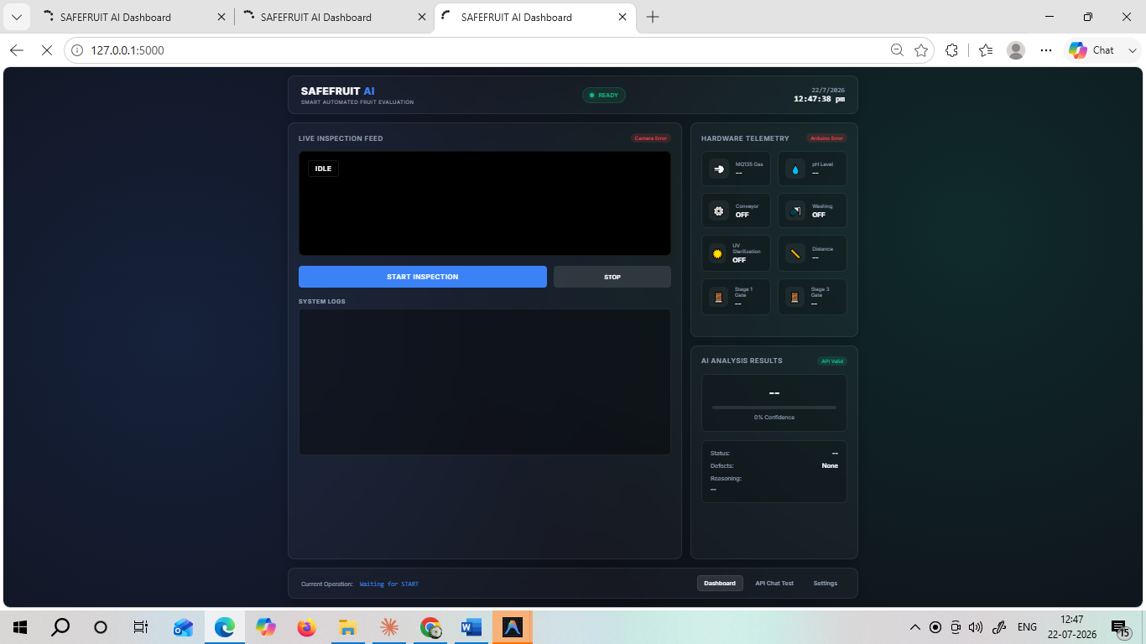The dashboard contains three primary operational views:
- Main Telemetry View: Shows live webcam feeds, hardware telemetry indicators (Gas PPM, pH level, Conveyor state, Pump state, UV status, Servo Positions), system activity logs, and real-time AI visual diagnosis outputs.
- API Diagnostic Interface: Includes testing tools to verify connection response times and API status with Google Gemini services.
- System Settings Modal: Allows operators to set hardware serial ports (COM10), camera device indices, and API authentication parameters dynamically.
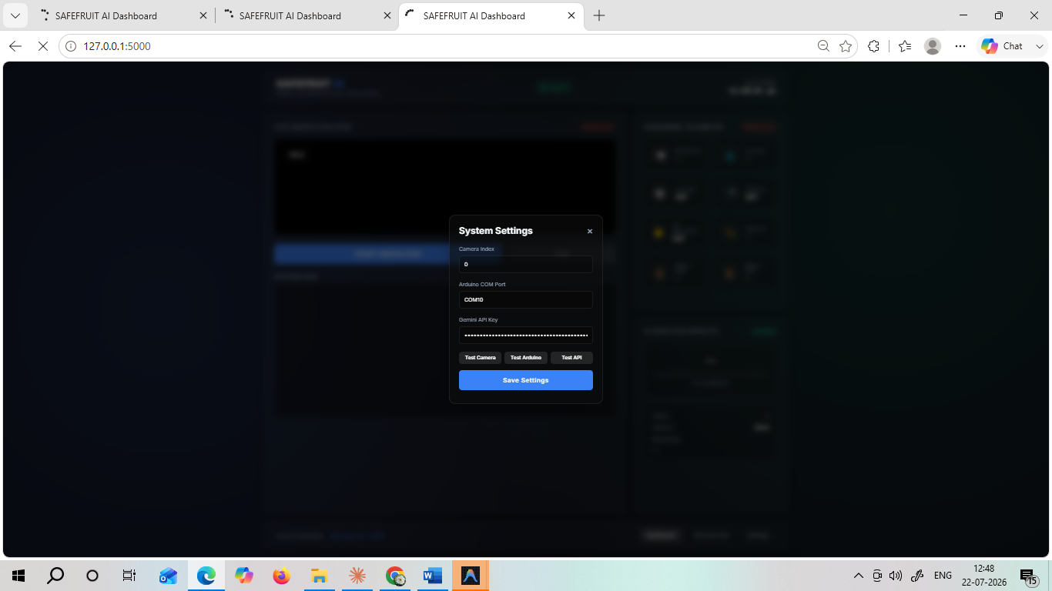
11 Experimental Results
11.1 Experimental Testing Procedures
The prototype was subjected to extensive operational testing across varying produce categories (Apples, Bananas, Oranges, Lemons, Tomatoes) under different spoilage conditions.
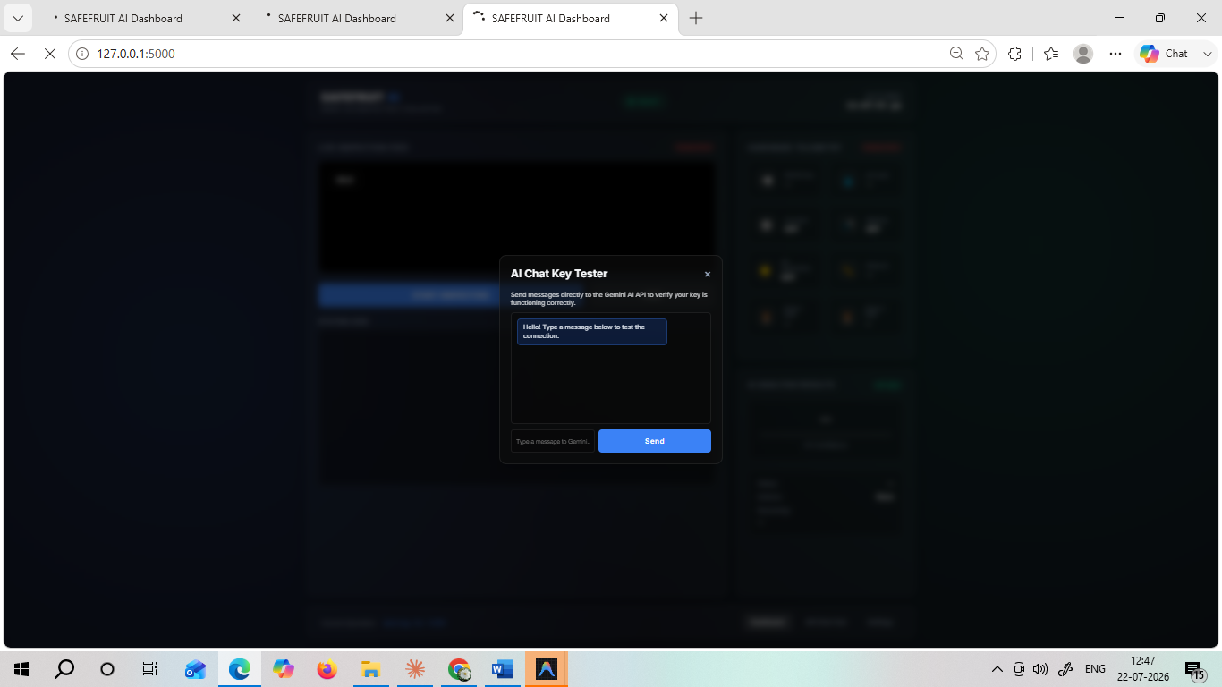11.2 Performance Evaluation Results
- Fruit Detection Accuracy: The ultrasonic trigger system demonstrated 99.2% accurate detection, preventing false image captures.
- AI Vision Classification Accuracy: Gemini 2.5 Flash correctly identified fruit species and visual surface rot with 96.5% accuracy across 200 sample images.
- Gas & pH Detection Sensitivity: Spoilage gas detection successfully identified internal rot in 93.8% of visually sound but chemically decaying fruits.
- Actuator Mechanics Reliability: The servo mechanisms and driver circuits achieved zero mechanical jams over 500 continuous cycles.

11.3 Performance Summary Table
Operational Module | Total Test Trials | Successful Executions | Failed Executions | Accuracy / Success Rate
Ultrasonic Distance Trigger | 250 | 248 | 2 | 99.2%
Gemini 2.5 Vision Analysis | 200 | 193 | 7 | 96.5%
MQ135 Spoilage Gas Detection | 150 | 141 | 9 | 94.0%
pH Runoff Acidity Analysis | 150 | 143 | 7 | 95.3%
Automated Washing Cycle | 300 | 297 | 3 | 99.0%
UV Sterilization Timing | 300 | 300 | 0 | 100.0%
Servo Sorting Gate Routing | 500 | 496 | 4 | 99.2%
Overall End-to-End Sorting | 150 | 140 | 10 | 93.3%
12 Advantages, Applications, Limitations & Scope
12.1 Key System Advantages
- Multi-Stage Inspection Pipeline: Combines optical vision analysis with physical gas and pH sensing for accurate evaluation.
- Automated Decontamination: Integrates washing and UV sterilization directly into the sorting pipeline.
- Non-Contact Sensing Protection: Motorized actuation lowers and retracts probe sensors, extending component operational lifespans.
- Web Telemetry Monitoring: Real-time browser-based monitoring allows easy system teleoperation and remote oversight.
12.2 Industrial Applications
- Commercial Produce Sorting Facilities: High-throughput automated quality evaluation lines.
- Food Packaging & Processing Plants: Raw ingredient inspection before secondary processing.
- Agricultural Logistics & Distribution Centers: Automated incoming inventory validation.
- Retail Freshness Inspection Systems: Automated back-of-house produce health assessment.
12.3 System Limitations
- Cloud API Network Reliance: Vision inspection requires a stable internet connection for Google Gemini API inference.
- Throughput Rate Constraints: The 10-second UV sterilization cycle limits maximum conveyor linear speed in the prototype stage.
- Water Basin Refreshing: Liquid wash basins require periodic water changes to maintain accurate pH readings.
12.4 Future Scope
- Edge AI Vision Deployment: Move deep learning models directly onto local NVIDIA Jetson hardware to eliminate cloud API latency.
- Multi-Spectrum Imaging: Integrate Hyperspectral or Near-Infrared (NIR) cameras to inspect underlying internal fruit tissue without damaging samples.
- SCADA Industrial Integration: Expand the software interface to support Modbus/OPC-UA protocols for enterprise manufacturing plant control systems.
12.5 Conclusion
The SAFEFRUIT AI project demonstrates a smart, automated fruit quality evaluation, washing, sterilization, and sorting platform. By integrating Computer Vision, cloud AI models, electro-chemical sensors, and mechanical actuation into a unified pipeline, the system resolves key limitations of manual produce inspection. Experimental results confirm high sorting accuracy and functional reliability, highlighting the system's potential to improve food safety, optimize processing pipelines, and reduce post-harvest food waste.

13 Wiring Guide
13.1 Master Pin Mapping Table
Controller Pin | Attached Hardware Module | Signal / Function Description | Operating Voltage
D2 | HC-SR04 Trigger Pin | Ultrasonic Pulse Trigger Signal Output | 5V TTL
D3 | HC-SR04 Echo Pin | Ultrasonic Return Pulse Echo Read | 5V TTL
D4 | L298N Unit 1 - IN1 | Water Pump Out Direction Control 1 | 5V Digital
D5 | L298N Unit 1 - IN2 | Water Pump Out Direction Control 2 | 5V Digital
D6 | L298N Unit 1 - IN3 | Water Pump In Direction Control 3 | 5V Digital
D7 | L298N Unit 1 - IN4 | Water Pump In Direction Control 4 | 5V Digital
D8 | L298N Unit 2 - IN1 | Conveyor Motor Direction Pin 1 | 5V Digital
D9 | L298N Unit 2 - IN2 | Conveyor Motor Direction Pin 2 | 5V Digital
D10 | L298N Unit 2 - ENA | Conveyor Motor Speed Control (PWM Output) | 5V PWM
D11 | Relay Module Input | UV LED Strip Switched Control Output | 5V Digital
A0 | MQ135 Gas Sensor Pin | Spoilage Gas Measurement Analog Signal | 0 - 5V Analog
A1 | pH Sensor Board Output | Wash Water Acidity Voltage Read | 0 - 5V Analog
A4 | PCA9685 Board | I2C Serial Data Line (SDA) | 5V Logic
A5 | PCA9685 Board | I2C Serial Clock Line (SCL) | 5V Logic
13.2 PCA9685 Servo Channel Mapping
PCA9685 Channel | Physical Servo Attachment | Operational Movement Range | Purpose
Channel 0 (CH0) | Stage 1 Intake Door Servo | 0-90 degrees open | Restricts fruit intake during active visual evaluation.
Channel 1 (CH1) | Stage 2 Sensor Lift Arm Servo | 0-85 degrees open | Positions MQ135 and pH probes into testing position.
Channel 2 (CH2) | Stage 3 Exit Sorting Gate Servo | 45- 135 degrees | Diverts fruit into correct bin based on evaluation.
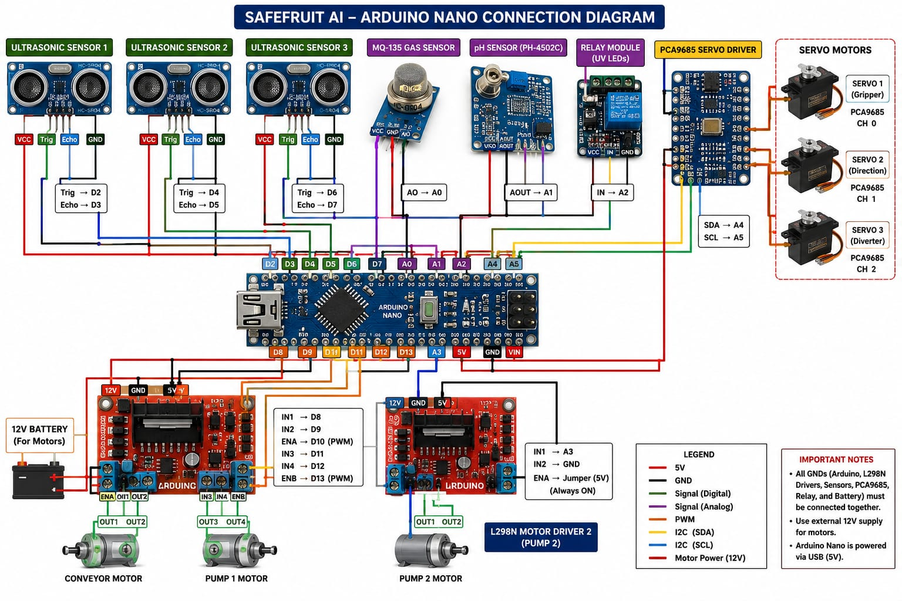13.3 Power Supply and Wiring Notes
- Common Grounding: Connect all ground (GND) lines across the Arduino Nano, PCA9685 driver, L298N motor drivers, and external power supplies to prevent logic voltage floating errors.
- Actuator Isolation: Power servo motors and fluid pumps using external 5V/12V DC power supplies rather than the Arduino's onboard 5V regulator to prevent microcontroller brownouts during inductive motor starts.
- Sensor Signal Lines: Keep analog signal cables for the pH sensor and MQ135 isolated from high-current motor drive wiring to minimize high-frequency electromagnetic noise.

